SpaceX Launch Programs  
Desktop View

Case-1: **on page load**

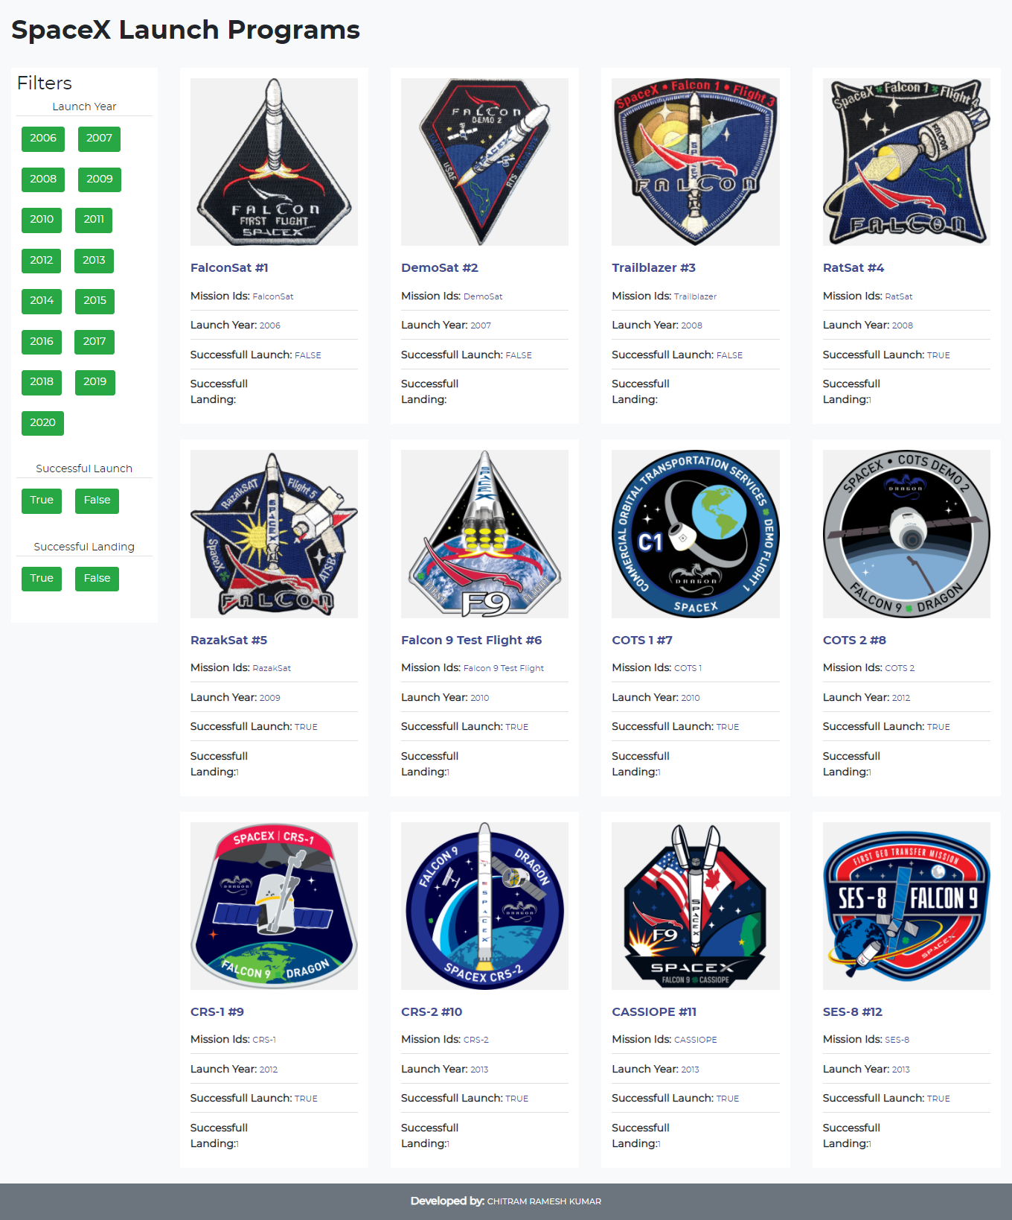

Case-2: **Launch Year Filter**

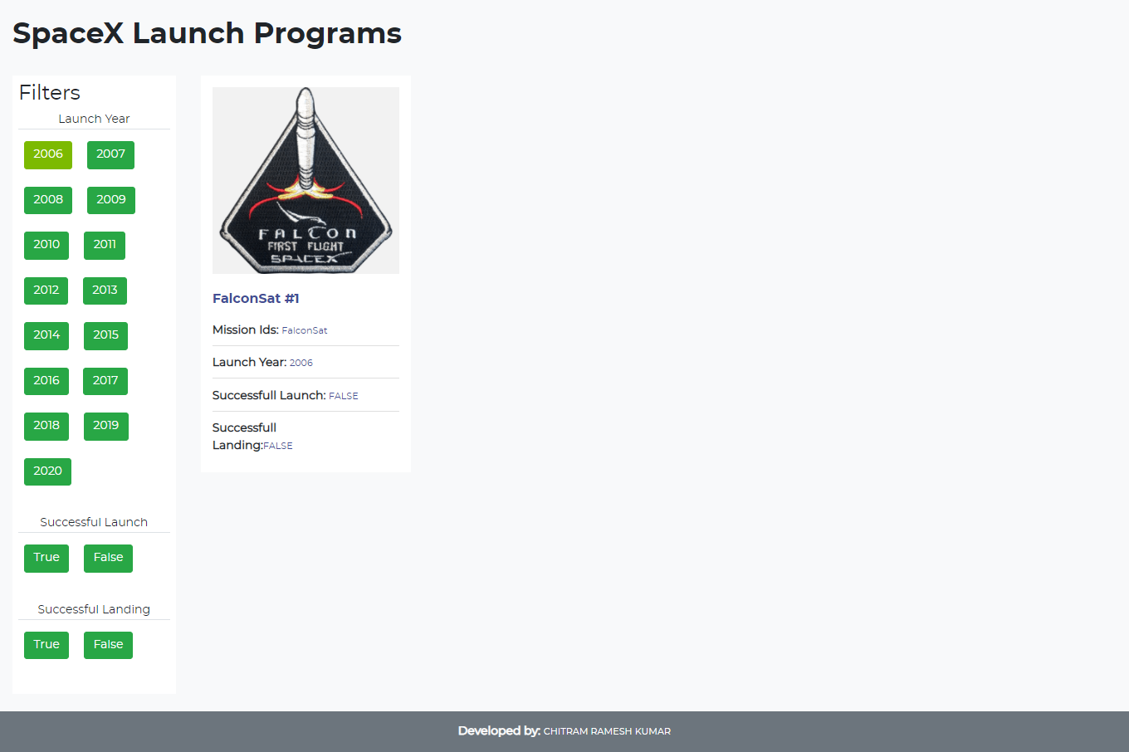

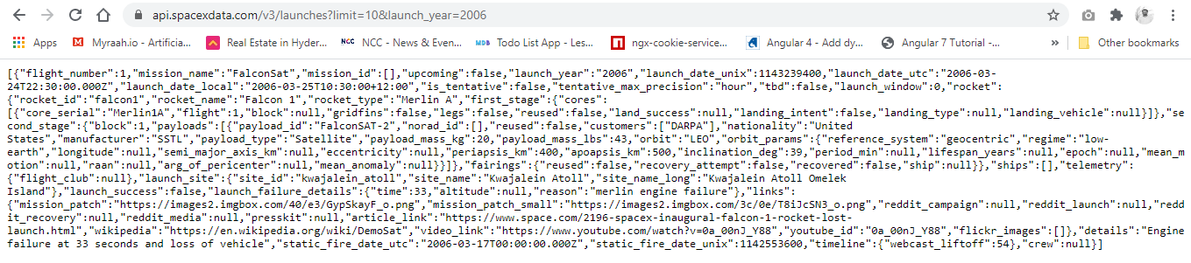

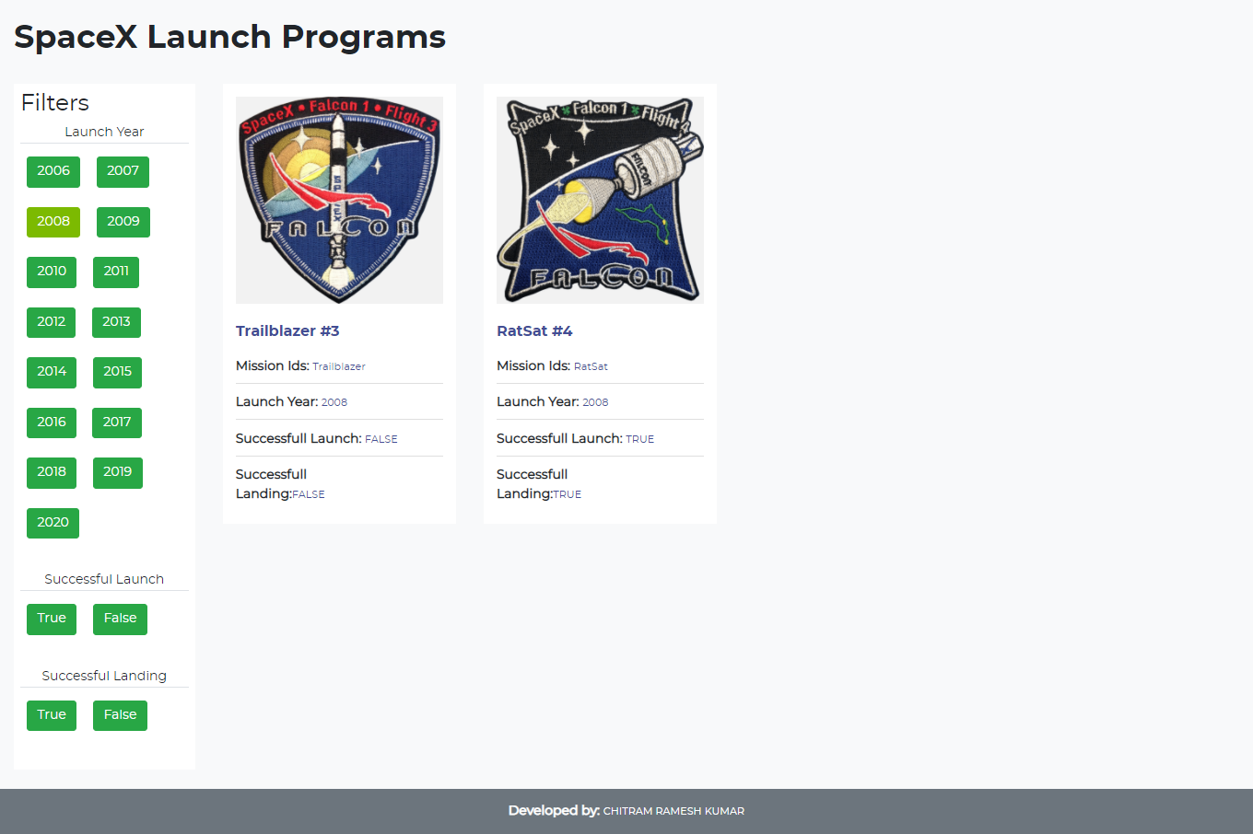 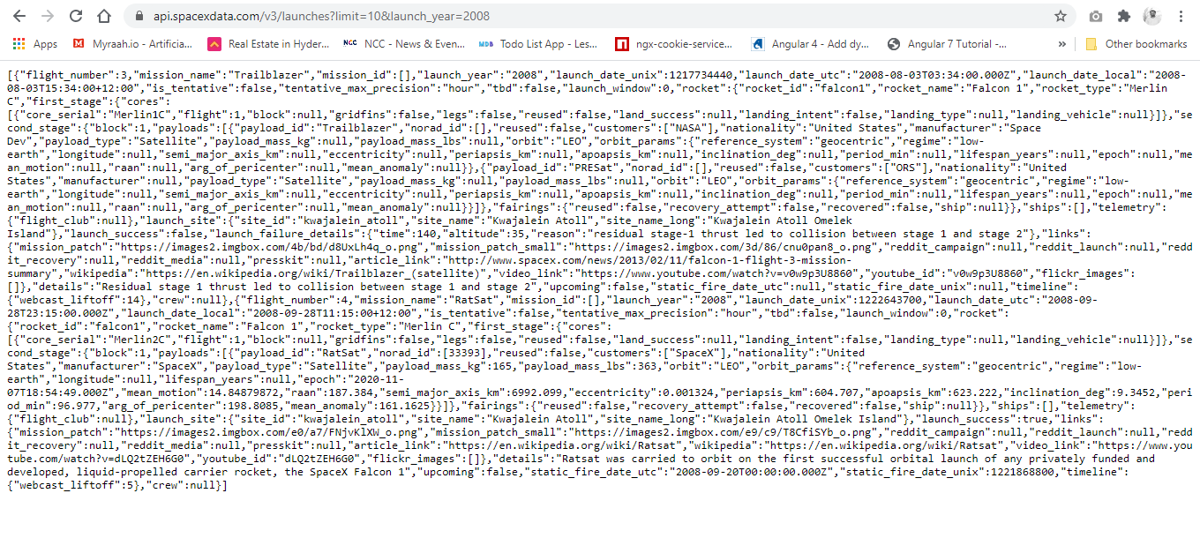

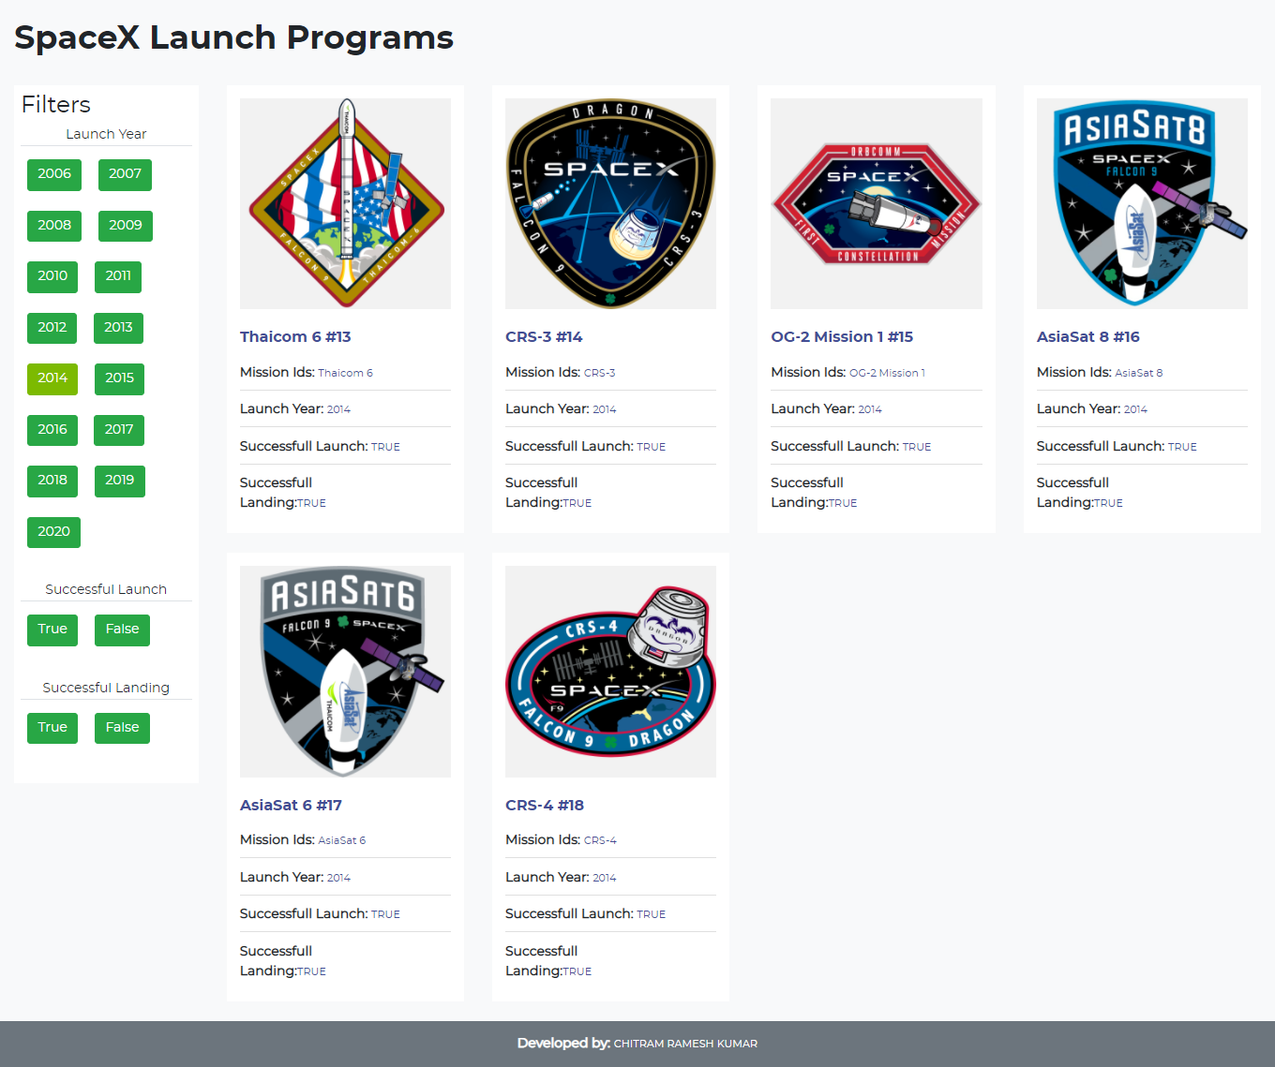

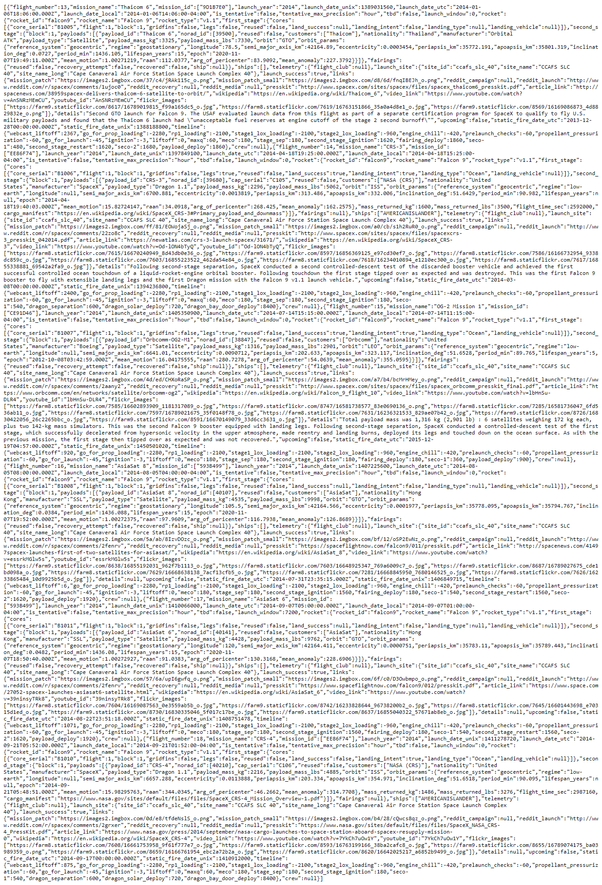

Case: **successful Launch**

Note: due to large screen I taken the screenshot of the my machine

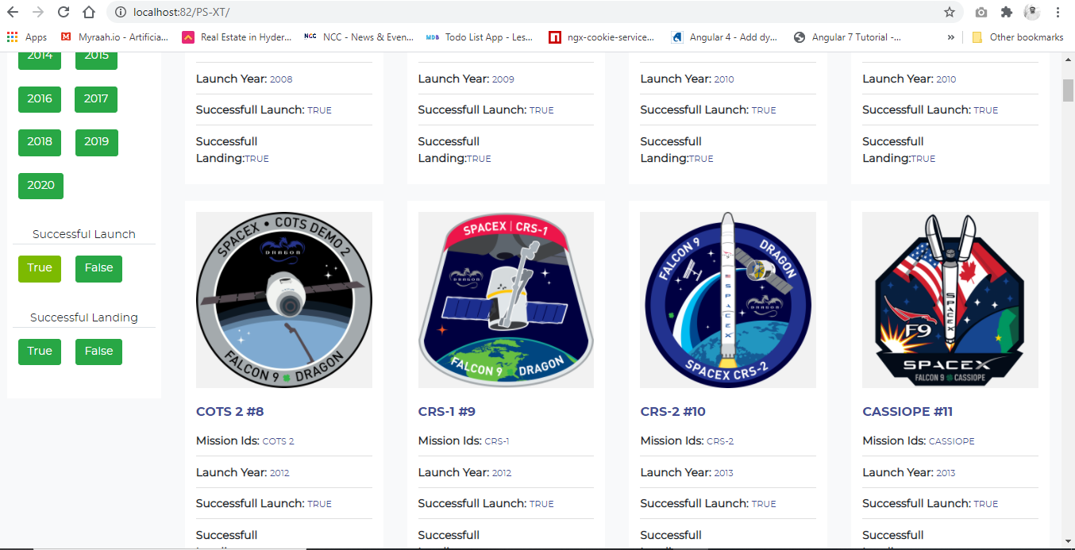

Case: **successful Landing**

Note: due to large screen I taken the screenshot of the my machine

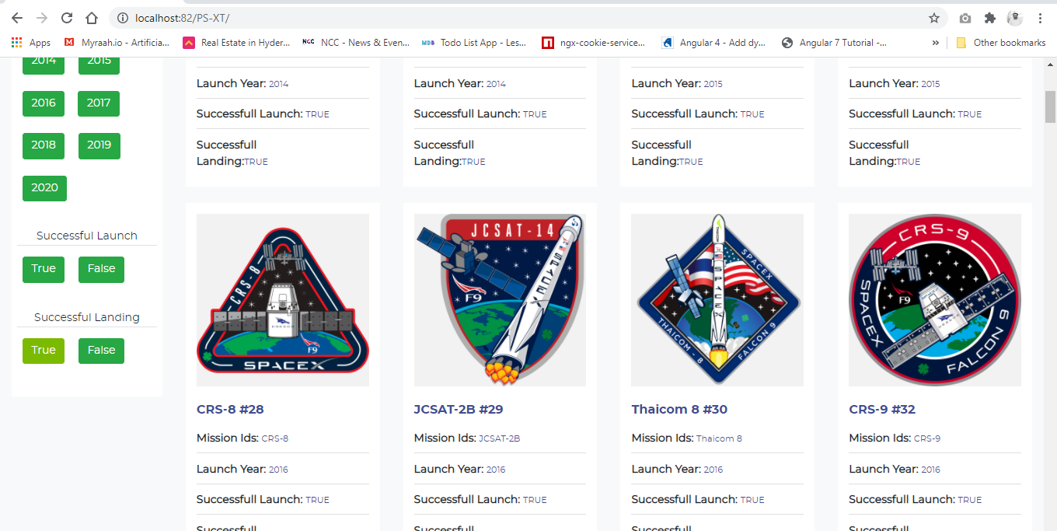

Case: **All Selection of Filters**

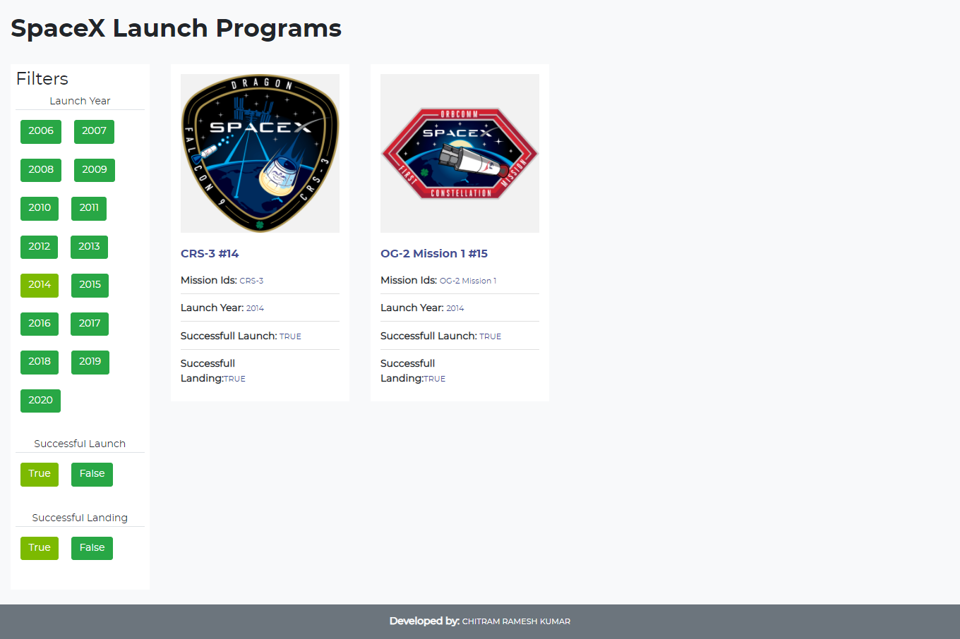

**Mobile View for MOTO G4**

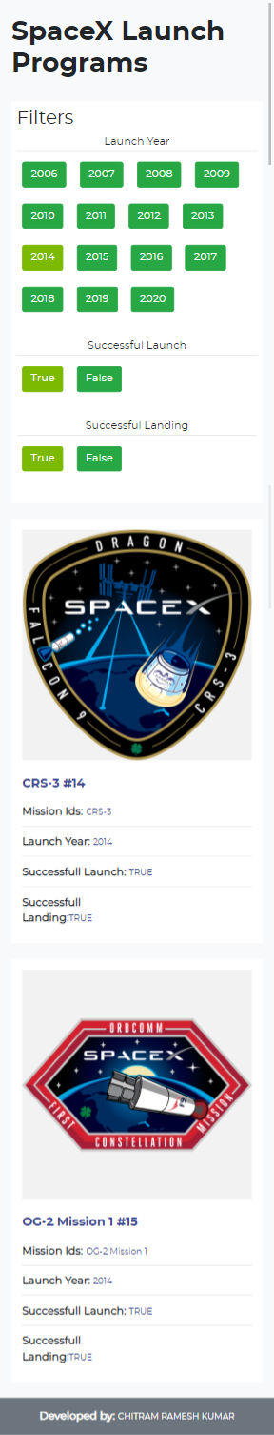

**Mobile View for iphone6/7/8**

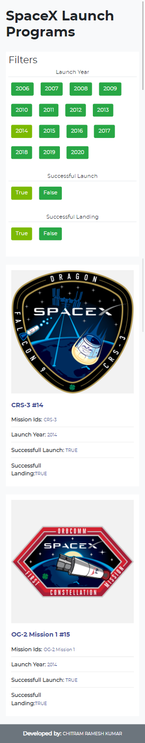

**iPad pro view**

